SP4 Ronald F. Neal
34W 028
Died January 17, 1969
A Troop 3rd Squadron 4th US Cavalry
25th Infantry Division
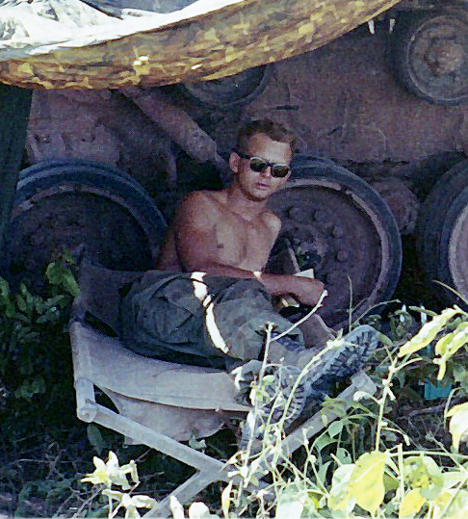
“Here’s to us who fought for it,
The sheltered shall never know
The price or glory of freedom.”
By an anonymous Vietnam Soldier

I served in Vietnam with Ronald

