CPT John L. Barovetto
33E 063
Died January 7, 1968
D Troop 3rd Squadron 4th US Cavalry 25th Inf Div
Second Tour
B Troop 1st Squadron 1st Cavalry Regiment
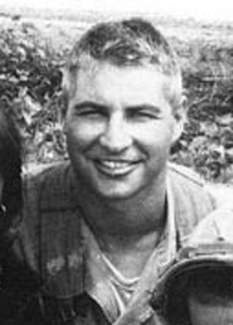
“Here’s to us who fought for it,
The sheltered shall never know
The price or glory of freedom.”
By an anonymous Vietnam Soldier

I served in Vietnam with John

