SP5 Billy W. Disheroon
03W 063
Died August 21, 1971
A Troop 3rd Squadron 4th US Cavalry 25th Inf Div
Second Tour
E Troop 2nd Squadron 11th Armored Cavalry
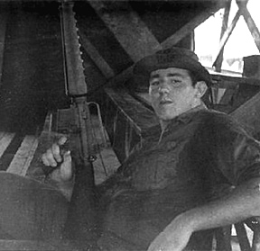
“Here’s to us who fought for it,
The sheltered shall never know
The price or glory of freedom.”
By an anonymous Vietnam Soldier

I served in Vietnam with Billy

